Краснопільська гімназія

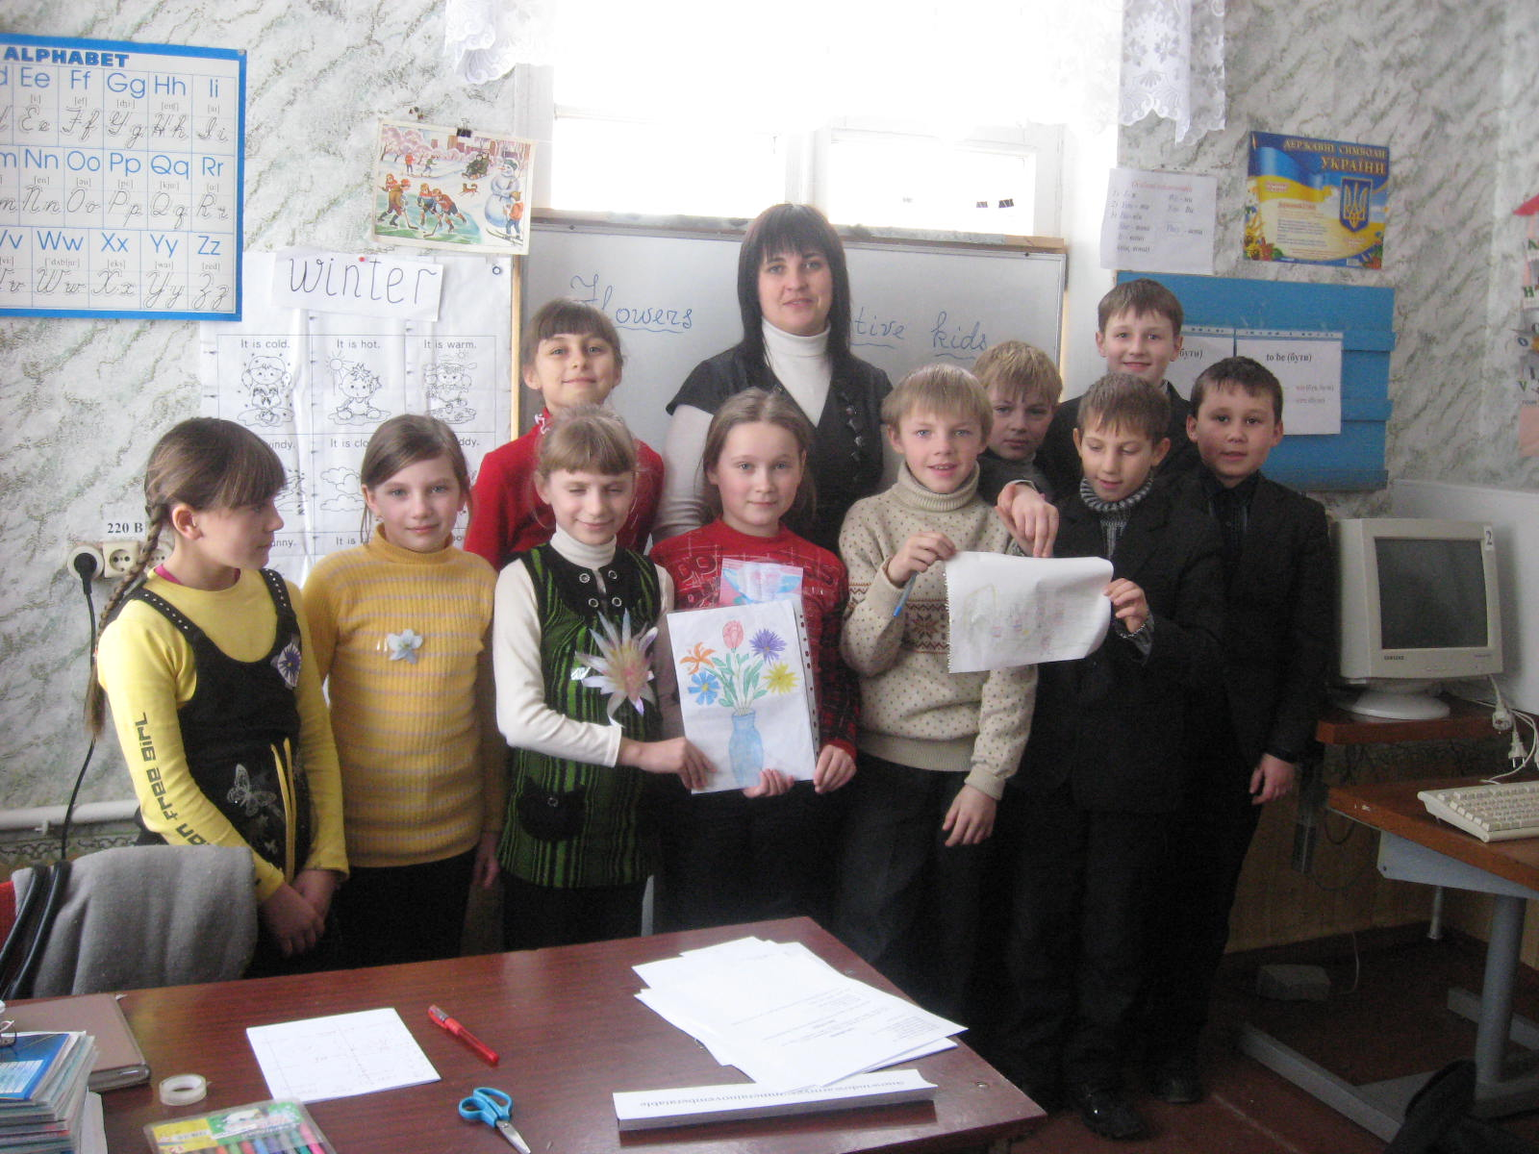

Тиждень англійської мови

Підготувала:
вчитель англійської мови
Підопригора Ю.В.

2010 – 2011 н.р.
КВК для учнів 4 класу
We are the best

Мета: залучити учнів до позакласної роботи з предмета;
розвивати творчі здібності учнів, пізнавальний інтерес, бажання й надалі вивчати англійську мову;
виховувати культуру мовлення та спілкування, повагу до співрозмовників під час роботи в групах

Обладнання: емблеми команд, аркуші паперу та кольорові олівці, картки із завданнями

Свято проводиться серед учнів 4 класу – команда дівчаток і команда хлопчиків.
- Привітання команд, візитка.
- Конкурс скоромовок (розминка).
- Конкурс «знайди 10 слів»
- Конкурс «Опиши свого друга»
- Конкурс «Кращий художник»
- Математичний конкурс

Both teams are invited to their places.

T. Good morning, our guests! We are happy to see you. Welcome to our party. Hello, dear girls and boys! We are glad to see you too. You look well today. Our girls are pretty and our boys are handsome.
It is time to start.

Task 1
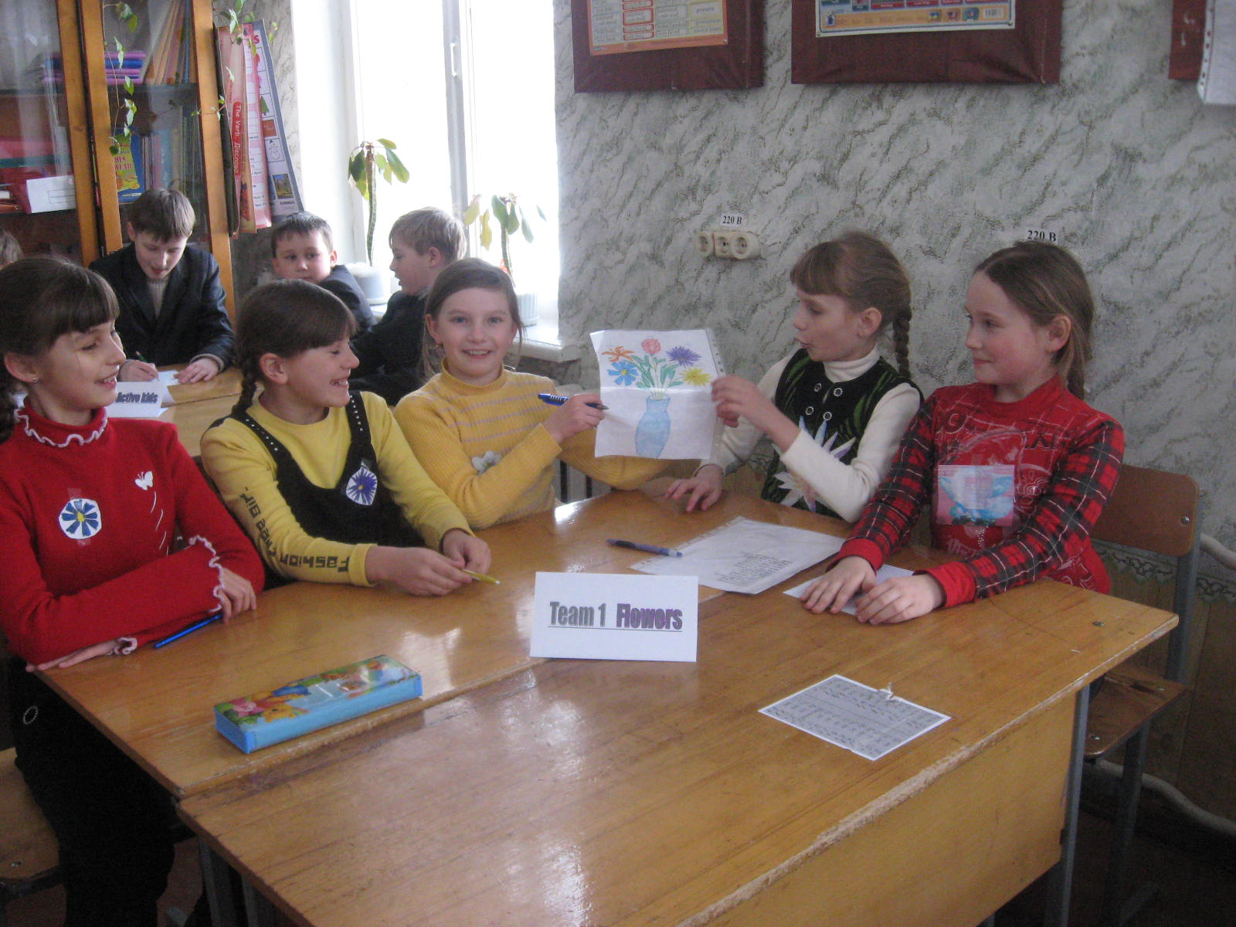
Team 1 Flowers
Good morning,
Good morning
And how do you do!
Good morning
Good morning
We are fine.
How are you?
The ship is sailing,
The flag is waving,
Hello, dear friends!
Hello, dear friends!
The sun is shining,
The stars are smiling.
Hello, dear friends! Hello!

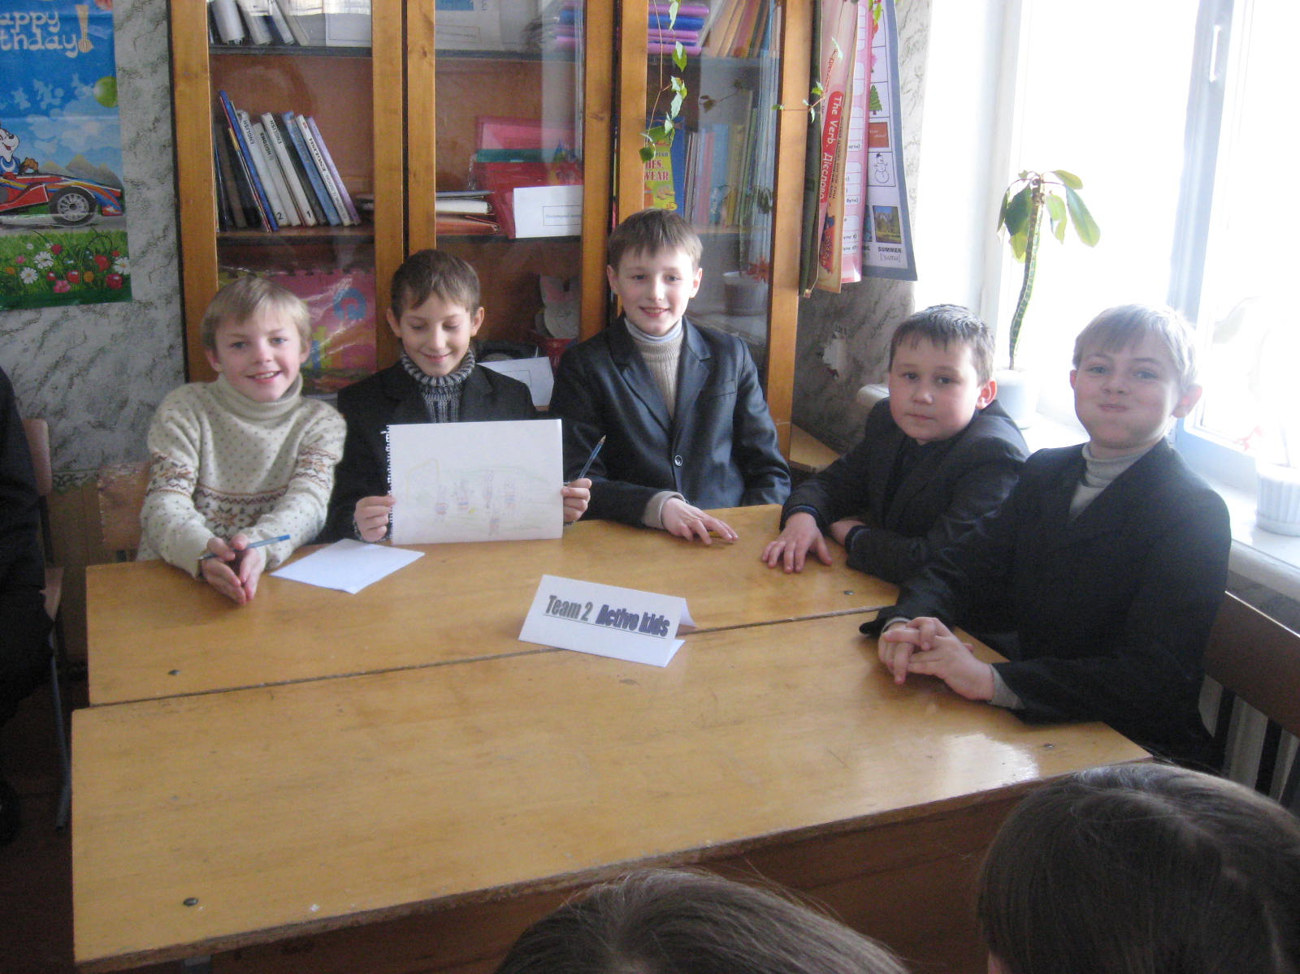
Team 2 Active kids
Hello, hello, hello, hey!
You are so smart today.
Hello, hello, hello, hey!
There are no clouds in the sky!
Hello, hello, hello, hey!
Everything will be OK!
Every team can get for 2 points for their presentation.
- That’s a good start!

Task 2

- And now it’s time to start the next task.
- Listen to the poem and repeat in English ( 2 points )
Red, red, red the rose,
Blue, blue, blue the dress,
Grey, grey, grey the rat
And so is the cat.
- That’s very nice of you!

Task 3Writing

- It’s time for the third task. ( 5 points )
- Find 10 words

Snowindowarmyesummerainovemberatable

Key: snow, window, warm, my, yes, summer, rain, November, rat, table.

- That’s excellent work!

Task 4 Speaking

- The next task is
- Describe your friend. Put these sentences into the right order.( 7 points )
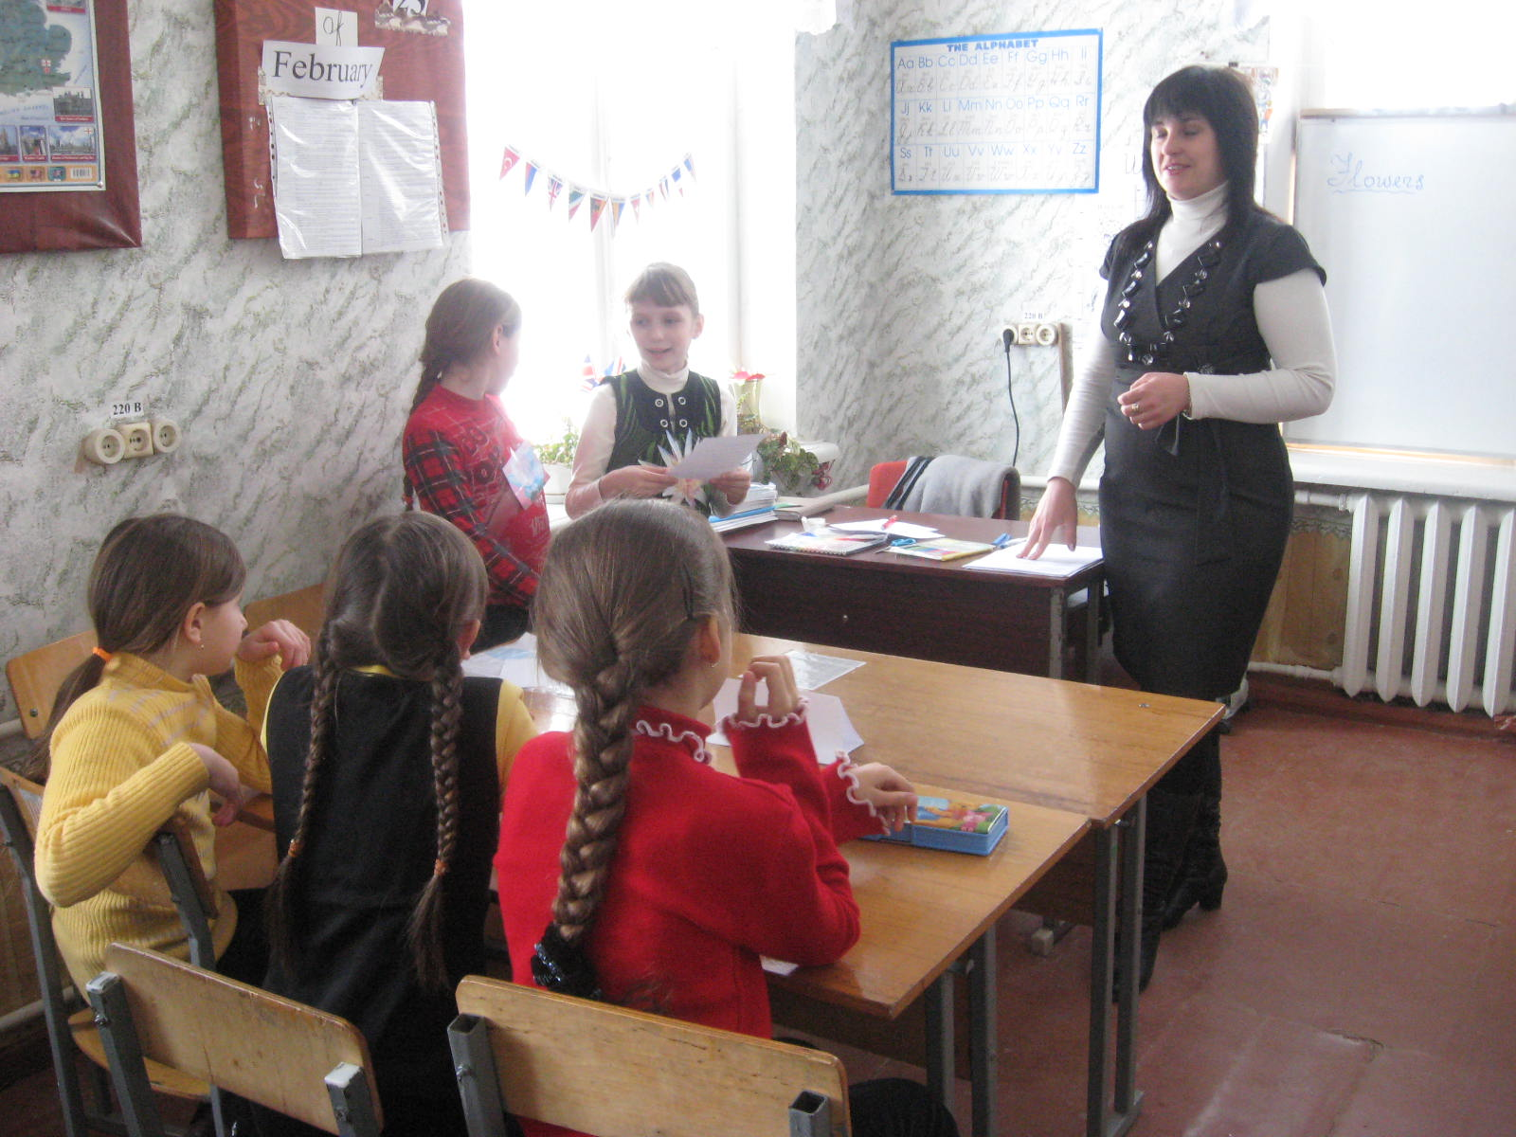
Key
His phone number is 76432 (7)
His favourite sport is football. (6)
His hobby is computer games. (5)
I have got a friend. (1)
He is a tall boy. (4)
He is from England. (3)
His name is Bill. He is ten. (2)

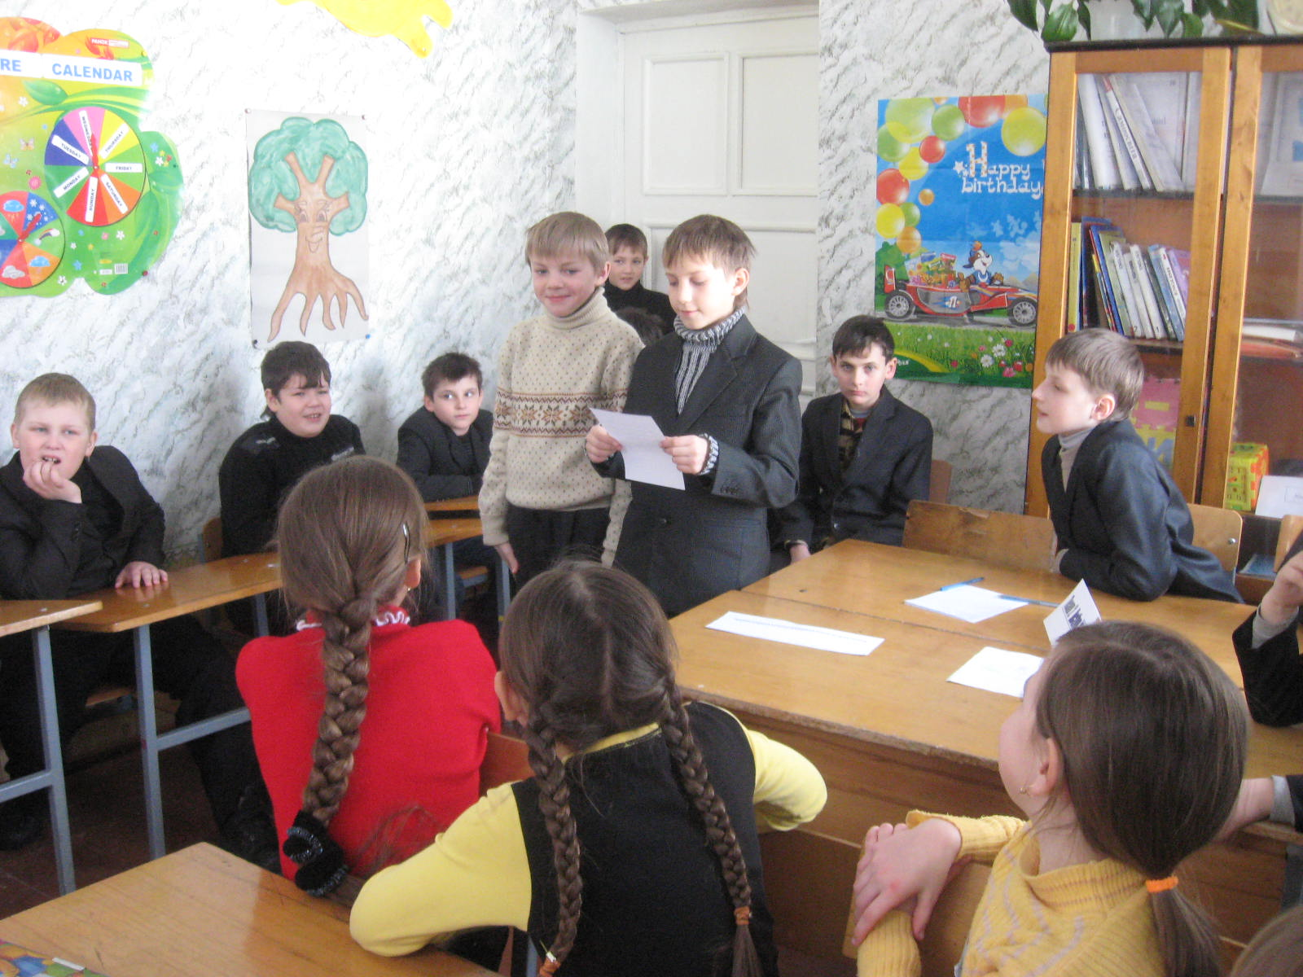
Her phone is 51147. (7)
Her favourite sport is tennis. (6)
Her hobby is dancing. (5)
I have got a friend. (1)
She is a small girl. (4)
She is from England. (3)
Her name is Mary. She is ten. (2)

- Nice of you!

Task 5 Relaxing

- Let’s little relax. You must draw 7 things which heard (7 points )
- Let’s draw. Draw a ball, a flower, a house, a table, a computer, a dog, a cat.

Task 6 Writing

- And the last task is guess 4 words and translate them into Ukrainian (4 points )

- grey-y+en=?
- face-ce+the+r=?
- nose-se+ten-en=?
- mouse-use+the+red-ed=?

Key: green, father, not, mother.

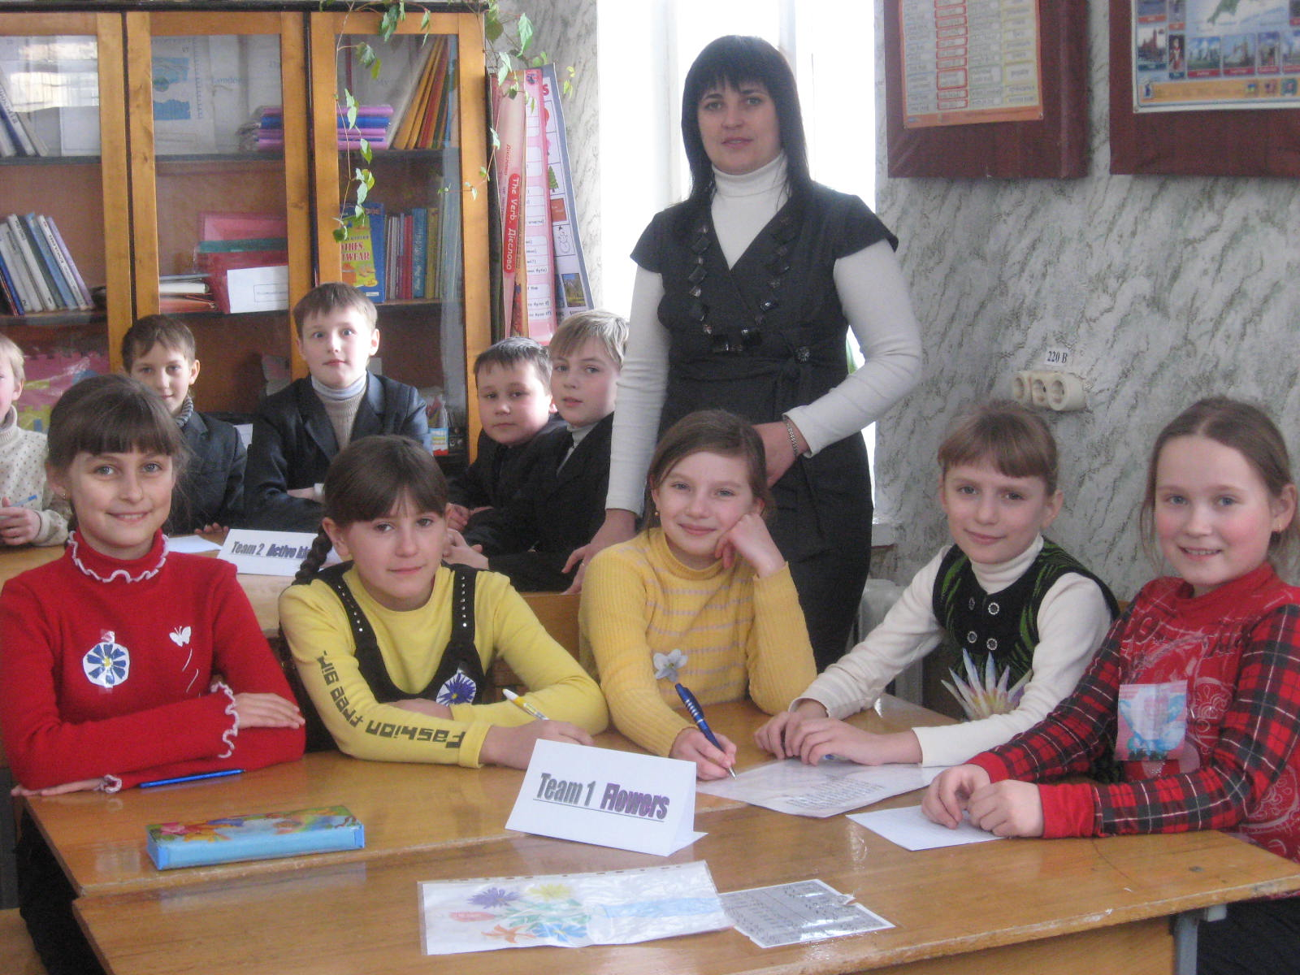
- You’re really trying hard. It’s time to finish our party. Let’s count your points.

